Assignment 2 : Sensitivity Analysis

Matthijs Brouns 1505157  
Hélène van Heijningen 4076850

# Rate sensitivity analysis

*Determine to which rates (inflows and outflows)* ***your model*** *is most sensitive.*

* *Select the output variables and the metric you’ll use to evaluate the sensitivity of these variables. Explain and justify your choices.*
* *Conduct a sensitivity analysis in which you vary all the rates in your model by + and – 1%. Show the resulting behavior plots in your report.*
* *Determine the rates that cause the highest sensitivity in each put variable.*
* *Discuss your results with reference to the model structure and model robustness.*
* *Select 5 rates and repeat the procedure with + and – 10% perturbation. Discuss if the results change or not.*

The output variables on which sensitivity was observed were chosen by their importance in the main structure of the model. In one of the initial model building phases we constructed a causal loop diagram (figure 1) which shows the system with its most important variables on a high level.

All variables in the causal loop diagram were chosen as output variables for the sensitivity analysis. These are:

* Water demand
* Infrastructure shortage
* Available funds
* Available infrastructure
* Staff availability
* Infrastructure miantenance

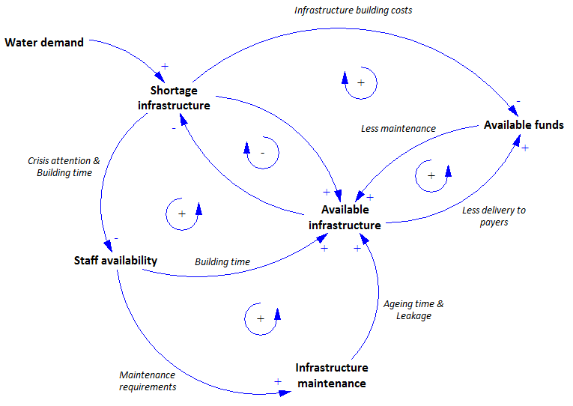

Figure 1: High level causal loop diagram

When performing the sensitivity analysis by varying the rates by 1% we noticed that there was no visual effect on these variables since the variation is simply too small. All the lines of the plot were drawn over one another and were indistinguishable. Therefore, the 1% variation plots are not shown in this report. Later on, the 10% variation plots will be shown

For determining the sensitivity the following formula was used:

This sensitivity was numerically estimated by using the trapezoid rule which gives the following formula:

The actual calculation of the sentivity value was done using a script we wrote in R. This script takes as input a directory containing csv result files from Vensim and the column names of the output variables you´re interested in, and returns a matrix with as the rows the experiment and as columns the output variables. The R script is added as an appendix to this document.

The results of the sensitivity analysis on each of the 6 output variables are shown in table 1. From this table it becomes clear that the 5 variables which show the largest sensitivity on the model are:

* Infrastructure aging
* Staff leaving
* Staff hiring
* Maintenance expenditures
* Income flow

For each of these variables an additional sensitivity analysis is done but this time varying the rates 10% instead of 1%. These results are also shown in table 1. A plot matrix of the effect of the 5 most sensitive rates on the output variables is shown in figure 2. Increasing the variation rates to 10% does not give massively different results. No behavioral sensitivity is observed and the sensitivity values in table 1 are roughly increased 10 times which is within line of expectation.

Results related to model robustness

We expect that the total water demand is only influenced by rates in the population system. The sensitivity analysis clearly shows this.

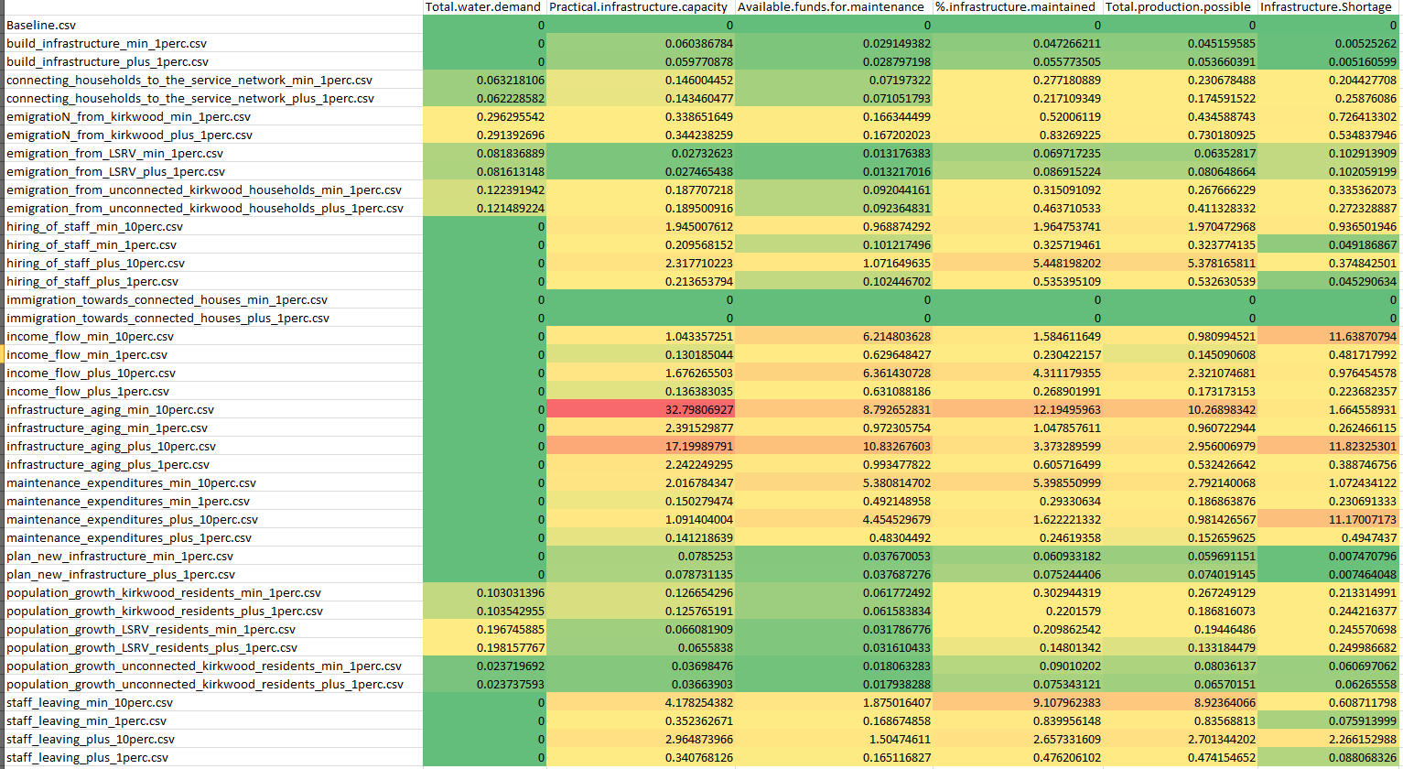

# Table function sensitivity analysis

*For at least one table function in your model, explore how sensitive your model is to changing the shape of the function by using a distortion function.*

* *Select the output variables, a distortion function type and the uncertainty ranges assigned to the parameters of this distortion function.*
* *Explain and justify your choices.*
* *Conduct a multi-variate automated sensitivity analysis and discuss the results in terms of the type and extent of the resulting sensitivity.*
* *Conduct uni-variate sensitivity analyses with at least two different values of the distortion function parameters.*
* *Discuss how these changes in the distortion function parameters affect (i) the shape of the distortion function, (ii) the shape of the table function and (iii) the model behavior.*

# Appendix A: R Script for sensitivity calculation

